**Project Development Phase**

**Model Performance Test**

|  |  |
| --- | --- |
| Date | 26 October 2023 |
| Team ID | NM2023TMIDO1678 |
| Project Name | Electronic Voting System(Block Chain) |
| Maximum Marks | 10 Marks |

**Model Performance Testing:**

Project team shall fill the following information when working for blockchain.

|  |  |  |
| --- | --- | --- |
| **S.No.** | **Parameter** | **Values** |
| **1.** | **Information gathering** | **Setup all the Prerequisite:**   1. **Visual Studio Code** 2. **Node js** 3. **Metamask** |

**Screenshot**

1)Visual Studio Code

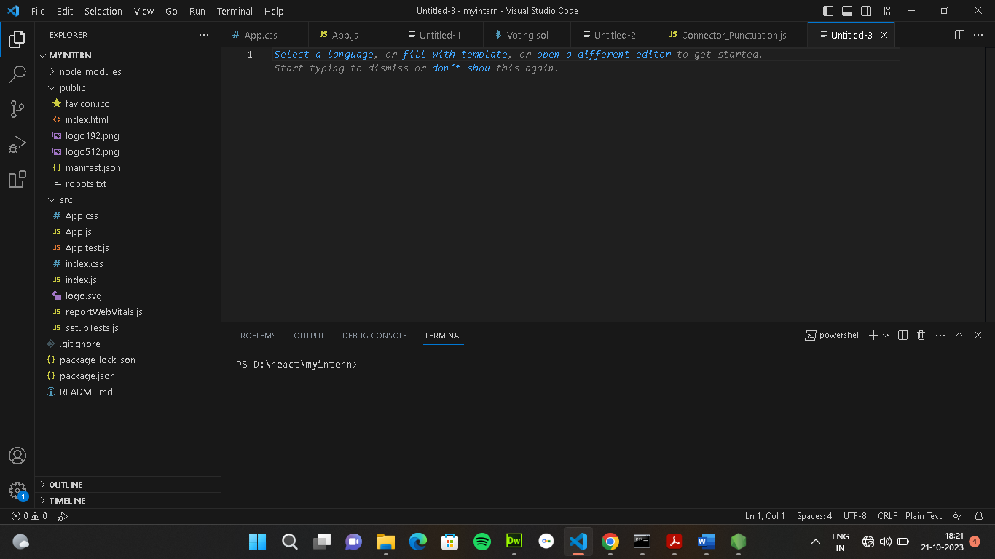

2)Node js

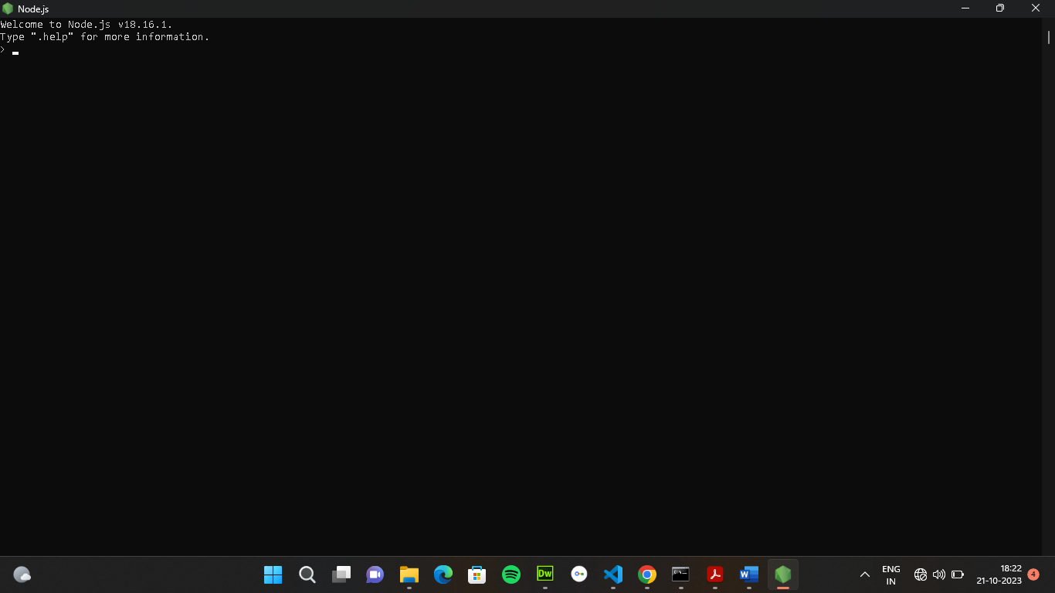

3)Metamask

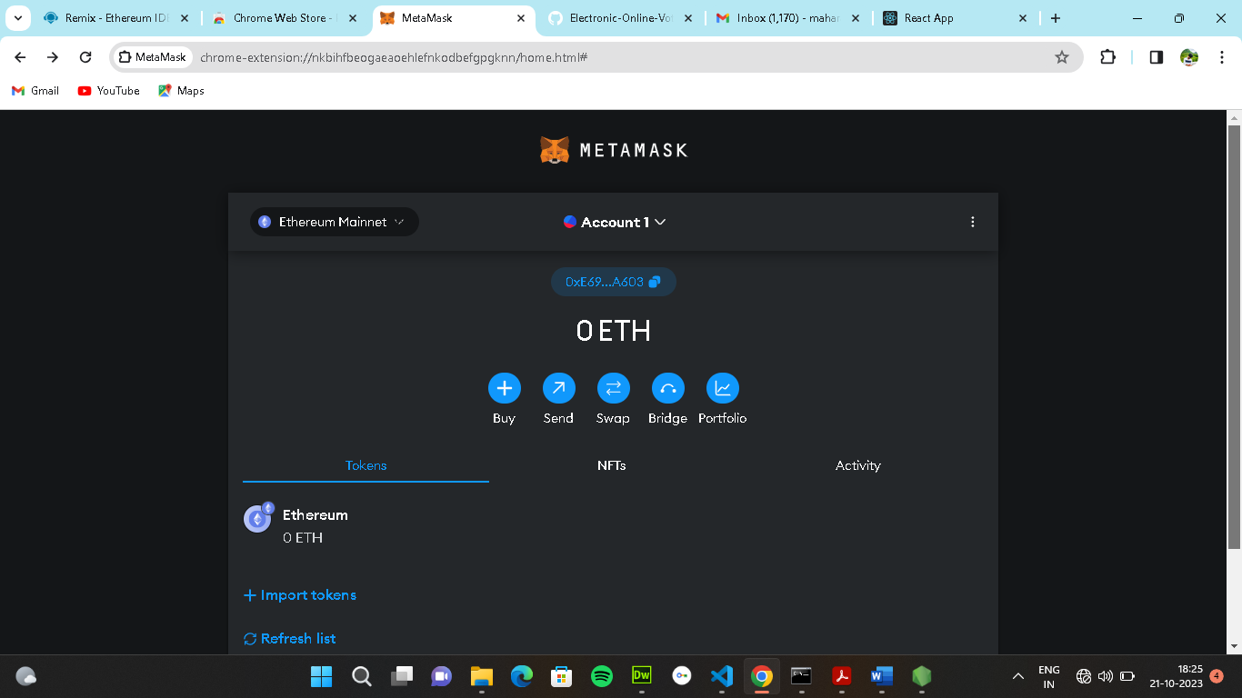

|  |  |  |
| --- | --- | --- |
| **S.No.** | **Parameter** | **Values** |
| **2.** | **Extract the zip files** | **Open to visual studio code** |

**Screenshot**

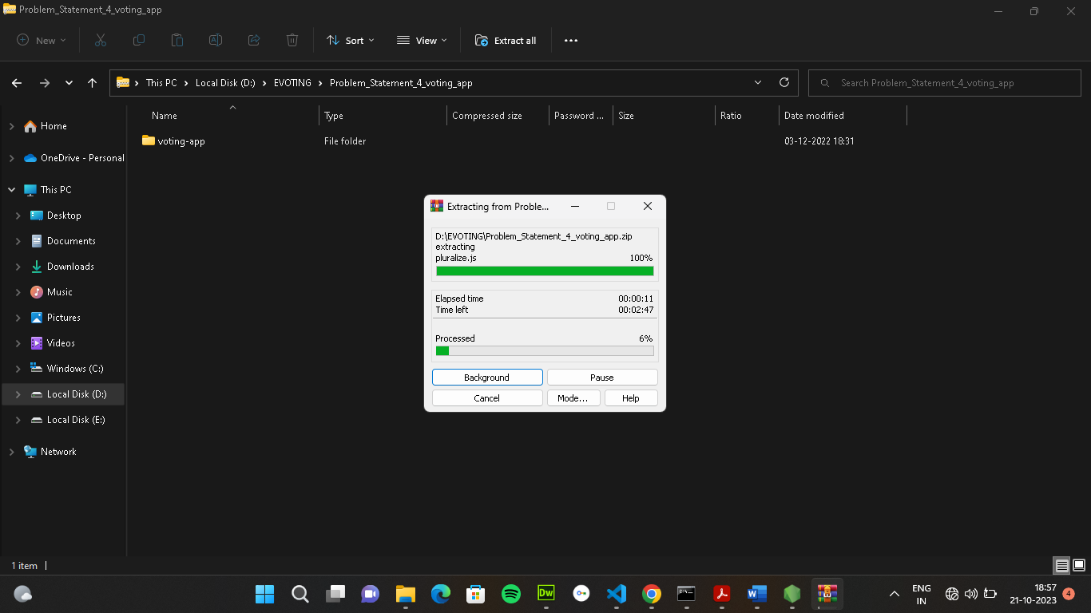

|  |  |  |
| --- | --- | --- |
| **S.No.** | **Parameter** | **Values** |
| **3.** | **Remix Ide platform**  **explorting**  **.** | **Deploy the smart contract code**  **Deploy and run the transaction. By**  **selecting the environment - inject**  **the MetaMask.** |

**Screenshot**

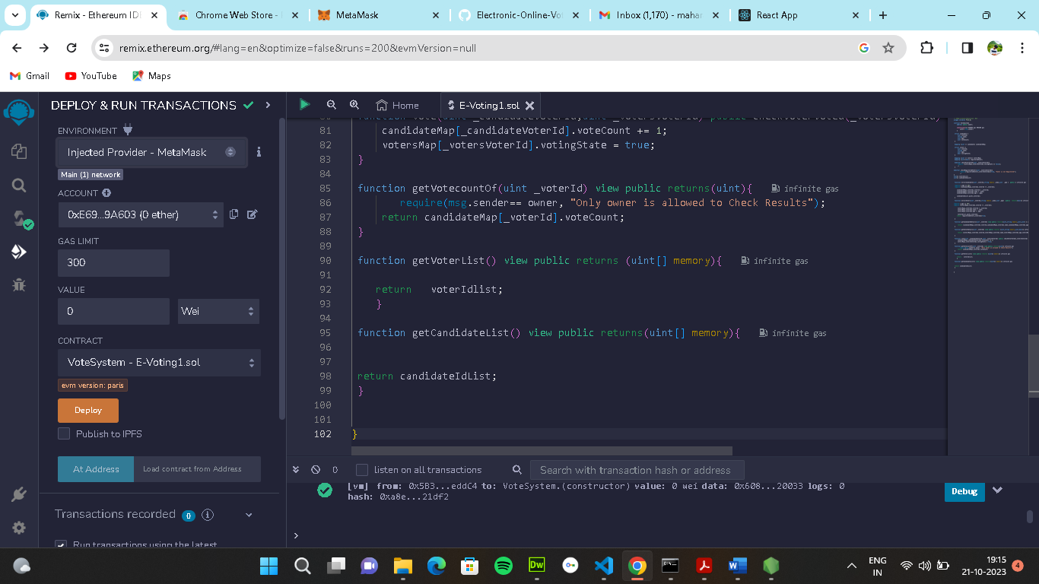

|  |  |  |
| --- | --- | --- |
| **S.No.** | **Parameter** | **Values** |
| **4.** | **Open file explorer** | **Open the extracted file and click on**  **the folder.**  **Open src, and search for utiles.**  **Open cmd enter commands**  **1.npm install**  **2.npm bootstrap**  **3. npm start** |

**Screenshot**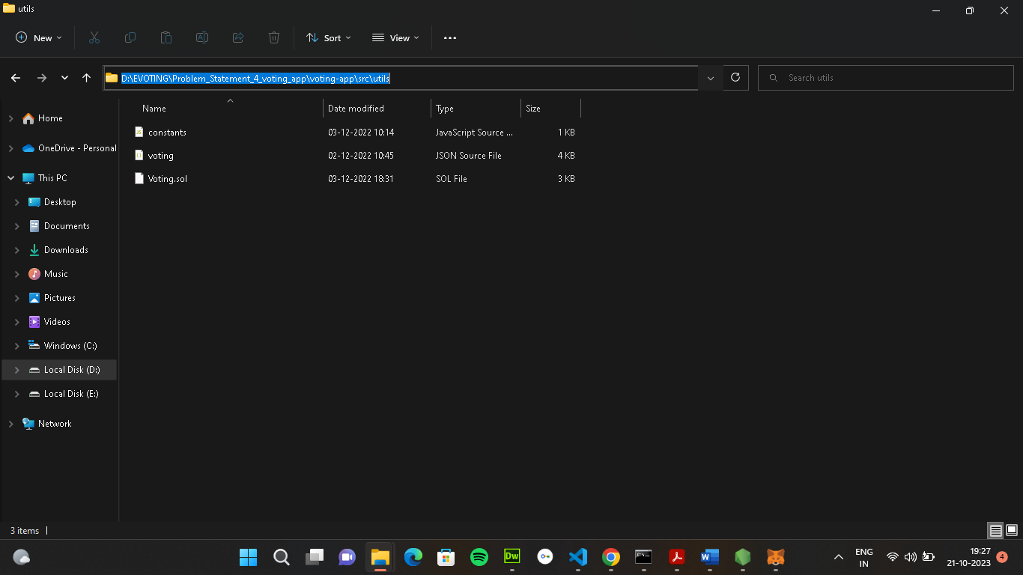

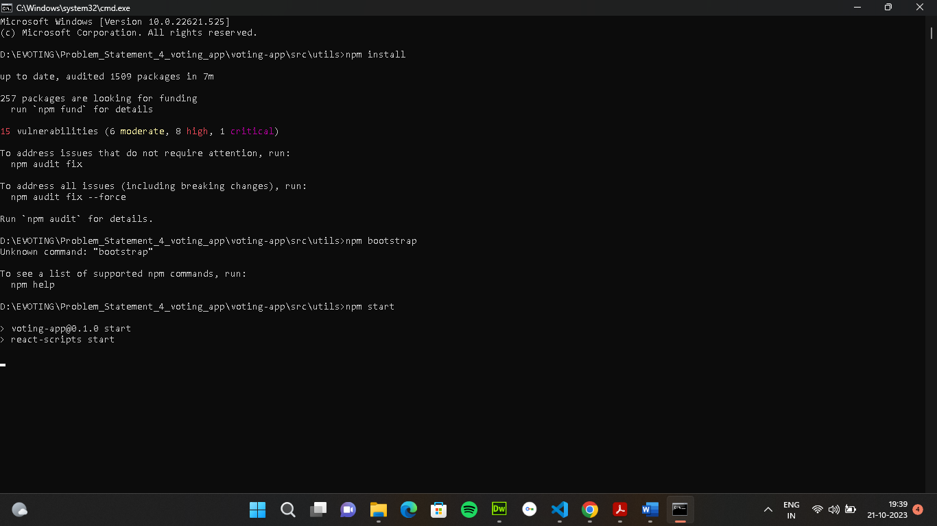

|  |  |  |
| --- | --- | --- |
| **S.No.** | **Parameter** | **Values** |
| **5.** | **{LOCALHOST IP ADDRESS}** | **Copy the address and open it to**  **chrome so you can see the front**  **end of your project.** |

**Screenshot**

